**Assignment – 3**

**Bootstrap 5**

**Q1. Use HTML and Bootstrap 5 to perform the following task –**

**a. Write “Bootstrap: A CSS framework” in any heading tag. Change the   
font size, text color, background color and align the text to the   
center using Bootstrap classes.**

**b. Write a paragraph about Bootstrap. Combine bootstrap classes and   
custom CSS to justify the text, increase the font size, change the   
text color, and change the line height.**

**c. Create a blue colored button for “Read More” using bootstrap   
classes. Align the button to the right of the page.**

**d. Visit this page - https://en.wikipedia.org/wiki/Bootstrap_(front-  
end_framework). Create a table with information like – bootstrap   
version, release date, and major features (use an unordered list).   
Make the table width 50% and center align the table. Style the   
table using Bootstrap.**

**e. Design a section with 3 blog cards with blog images, text, and a read   
more button. Use a bootstrap grid system to make the design   
mobile responsive.**

**f. Design a signup form with the fields – name, gender, DOB, address   
mobile, email, and password. Style the form using Bootstrap 5.   
Then Centre align the form using the bootstrap card and grid   
system.**

**CODE : q1.html**

<!-- Name : Uttam Kumar Jena -->

<!-- SIC: 23MMCI80 -->

<!DOCTYPE html>

<html lang="en">

<head>

<meta charset="UTF-8">

<meta http-equiv="X-UA-Compatible" content="IE=edge">

<meta name="viewport" content="width=device-width, initial-scale=1.0">

<title> Assignment Bootstrap</title>

<link rel="stylesheet" href="../bootstrap/css/bootstrap.min.css">

<style>

.para {

text-align: justify;

}

.card img {

height: 200px;

}

</style>

</head>

<body>

<h1 class="fs-3 text-primary bg-dark text-center">Bootstrap: A CSS Framework</h1>

<div class="container">

<p class="para fs-5 bg-dark text-light">Bootstrap is a free, open source front-end development framework for the

creation of websites and web apps. Designed to enable responsive development of mobile-first websites,

Bootstrap provides a collection of syntax for template designs. Lorem ipsum dolor sit amet consectetur,

adipisicing elit. Laborum commodi debitis illum numquam, eligendi recusandae aliquid totam, nobis cupiditate

cum eaque perferendis optio veritatis est aliquam eos nemo perspiciatis porro sint error mollitia qui! Cum

eius provident tenetur ipsa similique fuga libero praesentium illo aliquid nihil ea unde id asperiores

facilis eaque, sed consectetur sint molestias fugit non. Alias, vero. Doloribus sint sunt aliquid,

dignissimos, possimus dolor magnam nam consequuntur tempora obcaecati perferendis accusantium fuga ut cum

quae illo. Aperiam voluptate mollitia sit, vero accusantium dicta tempora ab veniam in eos unde eaque earum

veritatis placeat, distinctio, deleniti doloremque dolorum quisquam blanditiis. Sed aliquid numquam dolorum

dicta obcaecati mollitia nulla deleniti eum quam voluptatum corporis soluta, placeat rerum beatae odit eaque

tempora, doloremque nam optio? Veniam adipisci maiores, delectus quis excepturi quae sapiente explicabo rem

architecto, temporibus vel eaque quasi saepe nulla optio iste accusamus cupiditate? Voluptatem, voluptate.

Corrupti, tempora!</p>

<div class="text-end">

<a href="" class="btn btn-primary ">Read More</a>

</div>

<table class="table w-50 table-bordered m-auto">

<thead>

<tr>

<th>Bootstrap version</th>

<th>Release date</th>

<th>Major Freature</th>

</tr>

</thead>

<tbody>

<tr>

<td>Early beginnings</td>

<td>August 19, 2011</td>

<td>

<ul>

<li>various libraries</li>

<li>common design patterns</li>

<li> assets</li>

<li>open-source </li>

</ul>

</td>

</tr>

<tr>

<td>Bootstrap 2</td>

<td>January 31, 2012</td>

<td>

<ul>

<li> web pages adjusts dynamically</li>

<li>mobile phone Responsive</li>

</ul>

</td>

</tr>

<tr>

<td>Bootstrap 3</td>

<td>August 19, 2013</td>

<td>

<ul>

<li> Firefox 3.6 support</li>

<li>new plugin system</li>

<li> dropped Internet Explorer 7</li>

</ul>

</td>

</tr>

<tr>

<td>Bootstrap 4</td>

<td>on October 29, 2014</td>

<td>

<li>Replacing Less with Sass</li>

<li>CSS Flexible Box support</li>

<li>Dropping the Glyphicons icon font</li>

<li>Huge number[quantify] of utility classes</li>

<li>Adding navigation customization options</li>

<li>Adding responsive spacing and sizing utilities</li>

</td>

</tr>

<tr>

<td>Bootstrap 5</td>

<td>May 5, 2021</td>

<td>

<ul>

<li>Moving testing infrastructure from QUnit to Jasmine</li>

<li>Adding custom set of SVG icons[24]</li>

<li>Adding CSS custom properties</li>

<li>Enhanced grid system</li>

<li> Improved customizing docs</li>

<li>Updated forms</li>

<li>RTL support</li>

<li>Built in darkmode support</li>

</ul>

</td>

</tr>

</tbody>

</table>

</div>

<div class="container p-3">

<div class="row g-3">

<div class="col-md-4">

<div class="card" style="width: 18rem;">

<img src="p2.jpg" class="card-img-top" alt="...">

<div class="card-body">

<h5 class="card-title">Card title</h5>

<p class="card-text">Some quick example text to build on the card title and make up the bulk of

the card's content.</p>

<a href="#" class="btn btn-primary">Read More</a>

</div>

</div>

</div>

<div class="col-md-4">

<div class="card" style="width: 18rem;">

<img src="p2.jpg" class="card-img-top" alt="...">

<div class="card-body">

<h5 class="card-title">Card title</h5>

<p class="card-text">Some quick example text to build on the card title and make up the bulk of

the card's content.</p>

<a href="#" class="btn btn-primary">Read More</a>

</div>

</div>

</div>

<div class="col-md-4">

<div class="card" style="width: 18rem;">

<img src="p4.jpg" class="card-img-top" alt="...">

<div class="card-body">

<h5 class="card-title">Card title</h5>

<p class="card-text">Some quick example text to build on the card title and make up the bulk of

the card's content.</p>

<a href="#" class="btn btn-primary">Read More</a>

</div>

</div>

</div>

</div>

</div>

<div class="container mt-5">

<div class="row">

<div class="col-md-6 mx-auto">

<div class="card">

<div class="card-body">

<h5 class="card-title text-center">Signup Form</h5>

<form action="" method="POST">

<div class="mb-3">

<label for="name" class="form-label">Name:</label>

<input type="text" class="form-control" id="name" placeholder="Enter your name" required>

</div>

<div class="mb-3">

<label for="gender" class="form-label">Gender:</label> <br>

<input type="radio" id="male" name="gender" value="male">

<label for="male">Male</label>

<input type="radio" id="female" name="gender" value="female" class="ms-2">

<label for="female">Female</label>

</div>

<div class="mb-3">

<label for="dob" class="form-label">Date of Birth:</label>

<input type="date" class="form-control" id="dob" required>

</div>

<div class="mb-3">

<label for="address" class="form-label">Address:</label>

<textarea class="form-control" id="address" rows="3" placeholder="Enter your address" required></textarea>

</div>

<div class="mb-3">

<label for="mobile" class="form-label">Mobile:</label>

<input type="tel" class="form-control" id="mobile" placeholder="Enter your mobile number" required>

</div>

<div class="mb-3">

<label for="email" class="form-label">Email:</label>

<input type="email" class="form-control" id="email" placeholder="Enter your email" required>

</div>

<div class="mb-3">

<label for="password" class="form-label">Password:</label>

<input type="password" class="form-control" id="password" placeholder="Enter your password" required>

</div>

<div class="d-grid">

<button type="submit" class="btn btn-primary">Submit</button>

</div>

</form>

</div>

</div>

</div>

</div>

</div>

<script src="../bootstrapdownlord/js/bootstrap.bundle.min.js"></script>

</body>

</html>

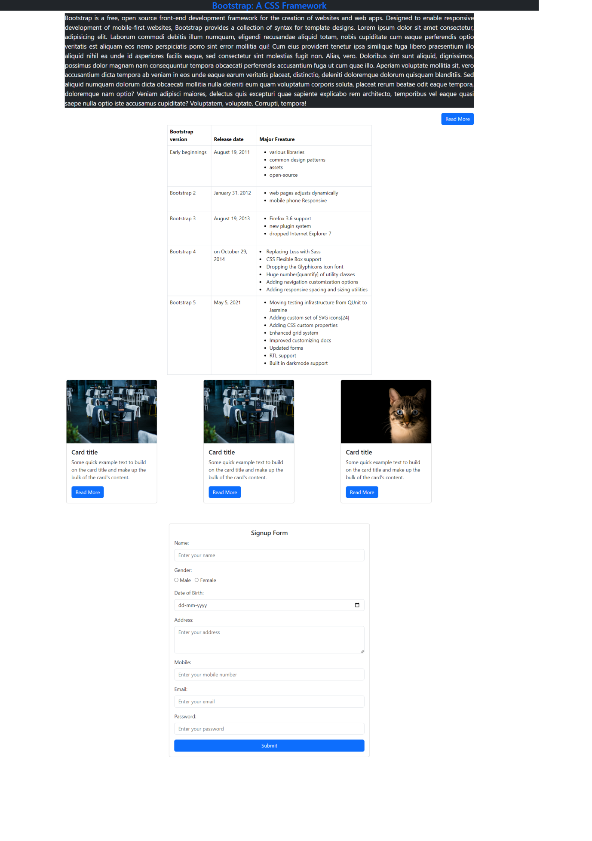**OUTPUT**

**Q2:** **Design the given template using HTML, CSS, and Bootstrap 5.**

**CODE : q2.html**

<!-- Name : Uttam Kumar Jena -->

<!-- SIC: 23MMCI80 -->

<!DOCTYPE html>

<html lang="en">

<head>

<meta charset="UTF-8">

<meta name="viewport" content="width=device-width, initial-scale=1.0">

<title>Uttam KJ</title>

<link rel="stylesheet" href="../../bootstrapdownlord/css/bootstrap.min.css">

<link rel="stylesheet" href="https://cdn.jsdelivr.net/npm/bootstrap-icons@1.11.3/font/bootstrap-icons.min.css">

<style>

*{

margin: 0;

padding: 0;

}

.about{

text-align: justify;

}

</style>

</head>

<body class="bg-black text-light">

<!-- navbar -->

<nav class="navbar navbar-expand-lg bg-black">

<a class="navbar-brand ms-2 text-light" href="#">UTTAM KJ</a>

<button class="navbar-toggler" type="button" data-bs-toggle="collapse"

data-bs-target="#navbarSupportedContent" aria-controls="navbarSupportedContent" aria-expanded="false"

aria-label="Toggle navigation">

<span class="navbar-toggler-icon"></span>

</button>

<div class="collapse navbar-collapse" id="navbarSupportedContent">

<ul class="navbar-nav ms-auto mb-2 mb-lg-0">

<li class="nav-item">

<a class="nav-link text-light " href="#home">Home</a>

</li>

<li class="nav-item">

<a class="nav-link text-light" href="#about">About</a>

</li>

<li class="nav-item">

<a class="nav-link text-light" href="#acc">Accademics</a>

</li>

<li class="nav-item">

<a class="nav-link text-light" href="#skill">Skills</a>

</li>

<li class="nav-item">

<a class="nav-link text-light " href="#project">project</a>

</li>

</div>

</nav>

<div class="container g-5">

<!-- home -->

<div class="row g-5" id="home">

<div class="col-md-6 text-center pt-5 ">

<img src="dp.jpeg" alt="" height="200px" width="200px" class="rounded-circle border border-light border-5 mt-5 ">

</div>

<div class="col-md-6 p-5 ">

<p class="btn btn-info rounded-0">Hi, I am</p>

<h1 class="fw-bold">Uttam Kumar Jena</h1>

<p>Master in Computer Application</p>

<p><i class="bi bi-envelope me-1"></i><a class="text-decoration-none text-light" href="mailto:uttamkumarjena507@gmail.com">uttamkumarjena507@gmail.com</a></p>

<p><i class="bi bi-phone me-1"></i>+91 8018886621</p>

<p><i class="bi bi-linkedin me-1"></i>linkedin.com/uttam406</p>

<p><i class="bi bi-github me-1"></i>github.ocm/uttam406</p>

</div>

</div>

<!-- about -->

<div class="row g-5 d-flex align-items-center " id="about">

<div class="col-md-6 ">

<h1 class="text-center">About Me</h1>

<p class="about lead ">Lorem ipsum dolor sit amet consectetur adipisicing elit. Quibusdam voluptatem iusto vel hic architecto dolores! Reiciendis laborum nobis aperiam quas deleniti consequuntur minus sunt porro tus obcaecati labore eveniet, deserunt cum dolorum ratione quas veniam non praesentium fugit? Ipsum quibusdam temporibus esse distinctio quos reprehenderit velit minus pariatur veniam expedita. Natus itaque dolor, voluptatum saepe vero a eveniet. Nisi natus excepturi nemo dolor maiores assumenda ea dolorum illum dolore inventore repudiandae soluta voluptatum commodi, perspiciatis architecto voluptatibus! Voluptatibus velit eius qui veniam eos repellat! Magni ullam quia error distinctio ex, veniam aperiam nulla beatae cum in saepe eaque esse ut accusantium? Quos reiciendis ratione odio, ab autem, natus praesentium dolores a id quas dicta modi optio cum numquam distinctio dolor rerum rem. Nam at tenetur delectus fugiat blanditiis numquam. Lorem ipsum dolor sit amet, consectetur adipisicing elit. Iste, natus aliquid. Lorem ipsum dolor sit. Lorem ipsum dolor sit.</p>

<a href="uttam.pdf" download="true" target="_blank" class="btn btn-info">Downlord CV</a>

</div>

<div class="col-md-6 d-none d-md-block">

<img class="img-fluid me w-100 h-100" src="prot.jpeg" alt="" >

</div>

</div>

<!-- academics -->

<div class="row g-3" id="acc">

<h1 class="text-center">My Accademic Records</h1>

<div class="col-md-4">

<div class="card p-2 m-0">

<div class="card-body">

<h1 class="card-title fs-bold fs-5">MCA</h1>

<p class="my-0"><i class="bi bi-mortarboard me-1"></i>Silicon institute of Technology</p>

<p class="my-0"><i class="bi bi-pencil me-1"></i>8.6(CGPA)</p>

<p class="my-0"><i class="bi bi-calendar-check me-1"></i>2023-2025</p>

</div>

</div>

</div>

<div class="col-md-4">

<div class="card p-2 m-0">

<div class="card-body">

<h1 class="card-title fs-bold fs-5">B.Sc</h1>

<p class="my-0"><i class="bi bi-mortarboard me-1"></i>Maharaja PurnaChandra Auto college</p>

<p class="my-0"><i class="bi bi-pencil me-1"></i>8.81(CGPA)</p>

<p class="my-0"><i class="bi bi-calendar-check me-1"></i>2021-2023</p>

</div>

</div>

</div>

<div class="col-md-4">

<div class="card p-2 m-0">

<div class="card-body">

<h1 class="card-title fs-bold fs-5">10 <sup>th</sup></h1>

<p class="my-0"><i class="bi bi-mortarboard me-1"></i>R.K. Govt. High School</p>

<p class="my-0"><i class="bi bi-pencil me-1"></i>8.6(CGPA)</p>

<p class="my-0"><i class="bi bi-calendar-check me-1"></i>2023-2025</p>

</div>

</div>

</div>

<div class="col-md-4">

<div class="card p-2 m-0">

<div class="card-body">

<h1 class="card-title fs-bold fs-5">MCA</h1>

<p class="my-0"><i class="bi bi-mortarboard me-1"></i>Silicon institute of Technology</p>

<p class="my-0"><i class="bi bi-pencil me-1"></i>8.6(CGPA)</p>

<p class="my-0"><i class="bi bi-calendar-check me-1"></i>2023-2025</p>

</div>

</div>

</div>

</div>

<!-- skills -->

<div class="row g-5" id="skill">

<h1 class="text-center">Technical Skills</h1>

<div class="col-md-6">

<label for="">C</label>

<div class="progress" role="progressbar" aria-label="Example with label" aria-valuenow="25" aria-valuemin="0" aria-valuemax="100">

<div class="progress-bar" style="width: 90%">90%</div>

</div>

<label for="">Java</label>

<div class="progress" role="progressbar" aria-label="Example with label" aria-valuenow="25" aria-valuemin="0" aria-valuemax="100">

<div class="progress-bar" style="width: 95%">95%</div>

</div>

<label for="">Python</label>

<div class="progress" role="progressbar" aria-label="Example with label" aria-valuenow="25" aria-valuemin="0" aria-valuemax="100">

<div class="progress-bar" style="width: 75%">75%</div>

</div>

<label for="">PHP</label>

<div class="progress" role="progressbar" aria-label="Example with label" aria-valuenow="25" aria-valuemin="0" aria-valuemax="100">

<div class="progress-bar" style="width: 65%">65%</div>

</div>

</div>

<div class="col-md-6">

<label for="">HTML</label>

<div class="progress" role="progressbar" aria-label="Example with label" aria-valuenow="25" aria-valuemin="0" aria-valuemax="100">

<div class="progress-bar" style="width: 90%">90%</div>

</div>

<label for="">CSS</label>

<div class="progress" role="progressbar" aria-label="Example with label" aria-valuenow="25" aria-valuemin="0" aria-valuemax="100">

<div class="progress-bar" style="width: 95%">95%</div>

</div>

<label for="">JavaScript</label>

<div class="progress" role="progressbar" aria-label="Example with label" aria-valuenow="25" aria-valuemin="0" aria-valuemax="100">

<div class="progress-bar" style="width: 60%">60%</div>

</div>

<label for="">Bootstrap</label>

<div class="progress" role="progressbar" aria-label="Example with label" aria-valuenow="25" aria-valuemin="0" aria-valuemax="100">

<div class="progress-bar" style="width: 80%">80%</div>

</div>

</div>

</div>

<!-- project -->

<div class="row g-3 mt-4" id="project">

<h1 class="text-center">My Projects</h1>

<div class="col-md-6 ">

<div class="card bg-dark text-light rounded-0">

<div class="card-body">

<h5 class="card-title">Quiz Application</h5>

<p class="my-0"><i class="bi bi-tools me-2"></i>Java Swing,JDBC,mySql</p>

<p class="card-text">Some quick example text to build on the card title and make up the bulk ofthe card's content. Lorem ipsum dolor sit amet consectetur adipisicing elit. Placeat consequuntur sequi impedit. Dolorum fugiat fuga quis aliquid accusamus voluptatibus repudiandae?</p>

</div>

</div>

</div>

<div class="col-md-6 ">

<div class="card bg-dark text-light rounded-0">

<div class="card-body">

<h5 class="card-title">Portfolio Website</h5>

<p class="my-0"><i class="bi bi-tools me-2"></i>HTML, CSS, Bootstrap</p>

<p class="card-text">Some quick example text to build on the card title and make up the bulk ofthe card's content. Lorem ipsum dolor sit amet consectetur adipisicing elit. Placeat consequuntur sequi impedit. Dolorum fugiat fuga quis aliquid accusamus voluptatibus repudiandae?</p>

</div>

</div>

</div>

<div class="col-md-6 ">

<div class="card bg-dark text-light rounded-0">

<div class="card-body">

<h5 class="card-title">Weather App</h5>

<p class="my-0"><i class="bi bi-tools me-2"></i>Java,JDBC,JSP</p>

<p class="card-text">Some quick example text to build on the card title and make up the bulk ofthe card's content. Lorem ipsum dolor sit amet consectetur adipisicing elit. Placeat consequuntur sequi impedit. Dolorum fugiat fuga quis aliquid accusamus voluptatibus repudiandae?</p>

</div>

</div>

</div>

<div class="col-md-6 ">

<div class="card bg-dark text-light rounded-0">

<div class="card-body">

<h5 class="card-title">Quiz Application</h5>

<p class="my-0"><i class="bi bi-tools me-2"></i>Java Swing,JDBC,mySql</p>

<p class="card-text">Some quick example text to build on the card title and make up the bulk ofthe card's content. Lorem ipsum dolor sit amet consectetur adipisicing elit. Placeat consequuntur sequi impedit. Dolorum fugiat fuga quis aliquid accusamus voluptatibus repudiandae?</p>

</div>

</div>

</div>

</div>

</div>

<!-- footer -->

<footer>

<p class="text-center m-5">2024 @uttam Kumar jena</p>

</footer>

</body>

</html>

**OUTPUT:**

